Food & Essentials
Chemists open on Christmas Day
Chemist | Address | Opening Times
Alpharm Pharmacy | 116 Plumstead High Street, Plumstead | 10am – 9pm
Eltham Pharmacy | 560 Westhorne Avenue, Eltham | 8.30am – 6.30pm
The Village Pharmacy | 9 The Village, Charlton | 8.30am -8.30pm

Holiday clubs and meals for Greenwich children aged 4 – 16 that are eligible for free school meals : https://www.royalgreenwich.gov.uk/holidayfoodandfun
SEVA street food
Free Christmas Dinner on 25th December at Woolwich Common Community Centre from 1pm-5pm. No need to register, you can just turn up at:
Please see the link below for more dates, locations and information.
No need to be alone this Christmas - here's what's open and when | Royal Borough of Greenwich (royalgreenwich.gov.uk)
Woolwich Common Community Centre
Leslie Smith Square
Woolwich
SE18 4DW
Foodbank: Christmas 2023 Opening Hours | Greenwich Foodbank
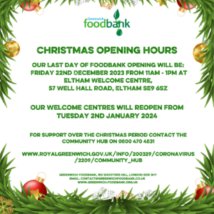

Gas & Electric
SELCE – Help with advice on electric and gas supply and managing costs. 0808 169 1779 free phone.
Also the Together for Winter campaign at the link below:
Greenwich Supports: Support for residents | Greenwich Supports | Royal Borough of Greenwich (royalgreenwich.gov.uk)
Help & Support
Someone to talk to:
The Mix: www.themix.org.uk 0808 808 4994 phone and text support for feelings (under 25’s)
Samaritans – Call free on116 123 at any time
Shout – Text MUM free 85258 at any time
Red Cross - 0808 196 3651 10am-6pm every day
Cry-sis - 08451 228 669 9am -10pm – help and advice for crying babies
The Family Lives -020 86552402/0808 800 2222 – closed 25th-28th December.
Open 9am-9pm apart from Christmas Eve and New Years Eve which is 9am – 1pm
Pandas foundation - 0808 1961 776 11am-10pm daily throughout the holidays
Mindline - 020 8853 1735 opening times are Monday – Friday: 10.30am – 4.30pm
Monday, Tuesday, Thursday and Friday: 6pm – 9pm, Saturday: 10.30am – 1.30pm
Oxleas urgent advice line: 0800 330 8590
Kooth – Help for young people, opening hours for chat service below: https://www.kooth.com/
Safety & Security:
Domestic Violence Helpline – 24hour 0808 2000 247
Greenwich Domestic Violence - 020 8317 8273, Monday- Friday 9am- 6pm
If you are in any doubt about yours or your child’s safety always ring 999

